Gough Group

<Un-serialised service calls>

<28.02.2018>

<Version 1.0>

**Document Control**

**Version**

|  |  |  |  |
| --- | --- | --- | --- |
| **Version** | **Date** | **Author(s)** | **Description of Change(s)** |
| 1.0 | 28.02.2018 | Diane George |  |
|  |  |  |  |
|  |  |  |  |

**Related Documents**

|  |  |  |
| --- | --- | --- |
| **Document Title** | **Document Location** | **Date** |
|  |  |  |
|  |  |  |
|  |  |  |

**Document Purpose:**

This is how to temporarily prevent an Un-serialised Service Call requiring a SMU capture date.

# How to prevent service segment from requiring a SMU capture date

## This is a temporary fix, handled telephonically with the user

In the *GGNZ* navigation bar, **select** *Service* from the dropdown menu

**Expand** *Service call* in Setup menu box

**Select** *Service report validation exception*

*The Service report validation exception window* opens

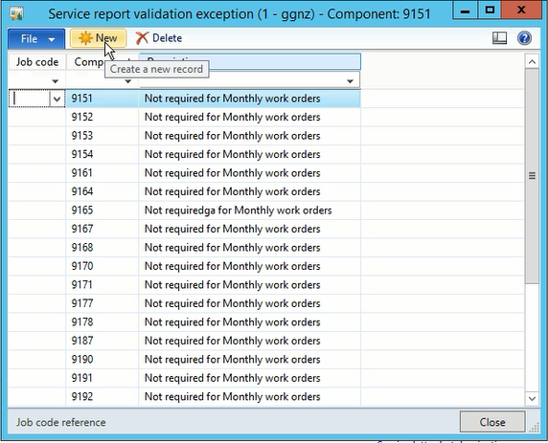

**Ask** the user for a *Job code* and *Component code*

**Click** *New icon*

(This creates a new line)

**Insert** the *Job code* and *Component code* (supplied by the user)

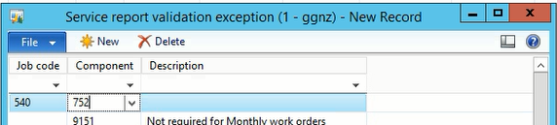

In the *Description field*, **Add** some unique text so that it’s easy to filter/find and remove later

**Refresh** your window

**Ask** the user to refresh their screen (This may take a few refreshes for your change to take effect)

After the user has processed their un-serialised service segment return to the line item you inserted and **Delete**